Centre for International Relations

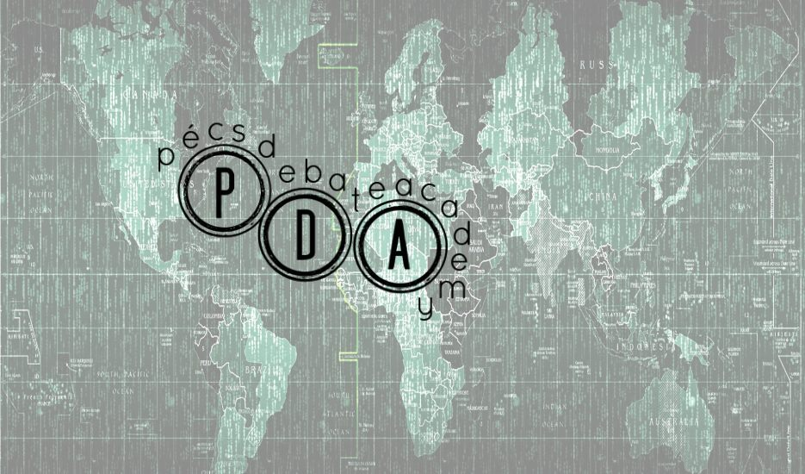
Pécs Debate Academy 2017- Summer School
’University Education and Student Life in the 21st Century’
July 28 – August 6, 2017
Pécs, Hungary

Preliminary Programme

July 28 (Friday) – Day of arrival, training session and teambuilding (6 hours)

14:00 - Team building and Intercultural training session
20:00 - Welcome event

The first day of the academy will be devoted to provide the students with the opportunity to know each other (and the trainers) better, even to learn the basic structure and issues of trainings and workshops by the way of introduction to intercultural education methods.

July 29 (Saturday) – Debate skills 1-3 (6 hours)

10:00 - Debate Skills 1.
14:00 - Debate Skills 2.
16:00 - Debate Skills 3.

This day is devoted to the introduction of course methodology and parliamentary debate.
The first occasion will focus on introducing the course aims and outcomes. Students will also begin to learn about the method of parliamentary debate (British Parliamentary Debate – BPD style).

July 30 (Sunday) – Sport and recreation day (6 hours)

10:00 - Health education and development in practice
14:00 - Sports day
20:00 - Optional Public Lecture

We believe in the saying “a sound mind in a sound body”, therefore, we will focus on physical activities and their consequences this day. By the help of an expert, we are going to introduce scientific principles of health education to our participants not just as a study, but also in practice.

July 31 (Monday) – First day of Academic Lectures and Trainings (6 hours)

09:00 - Opening Speech and Lecture 1.
10:30 - Lecture 2.
14:00 - Debate Training and Workshop 1.
15:30 - Debate Training and Workshop 2.

August 1 (Tuesday) – Second day of Academic Lectures and Trainings (6 hours)

09:00 - Lecture 3.
10:30 - Lecture 4.
14:00 - Debate Training and Workshop 3.
15:30 - Debate Training and Workshop 4.

August 2 (Wednesday) – Third day of Academic Lectures and Trainings (6 hours)

09:00 - Lecture 5.
10:30 - Lecture 6.
14:00 - Debate Training and Workshop 5.
15:30 - Debate Training and Workshop 6.

August 3 (Thursday) – Fourth day of Academic Lectures and Trainings (6 hours)
09:00 - Lecture 7.
10:30 - Lecture 8.
14:00 - Debate Training and Workshop 7.
15:30 - Debate Training and Workshop 8.

August 4 (Friday) – Fifth day of Academic Lectures and Trainings, Final Debate Tournament (6 hours)

09:00 - Lecture 9.
10:30 - Lecture 10.
15:00 - Final Debate Tournament

Owing to our long-term cooperation with the Judicial Council of Pécs, the Final Debate Tournament will be held in the building of the Courthouse of Pécs. Finalists would reveal what they learned during the week. Besides Best Team, the Best Speaker will also be rewarded. The competition is judged by professional debate trainers.

August 5 (Saturday) – Youth Conference and Round Table (6 hours)

10:00 - Display of Present and Future Universities
(plenary discussion of participants and experts, presentation of higher education systems of the regions from participants’ point of view)

August 6 (Sunday) – Summary and day of departure (6 hours)

08:00 - Summary Workshop

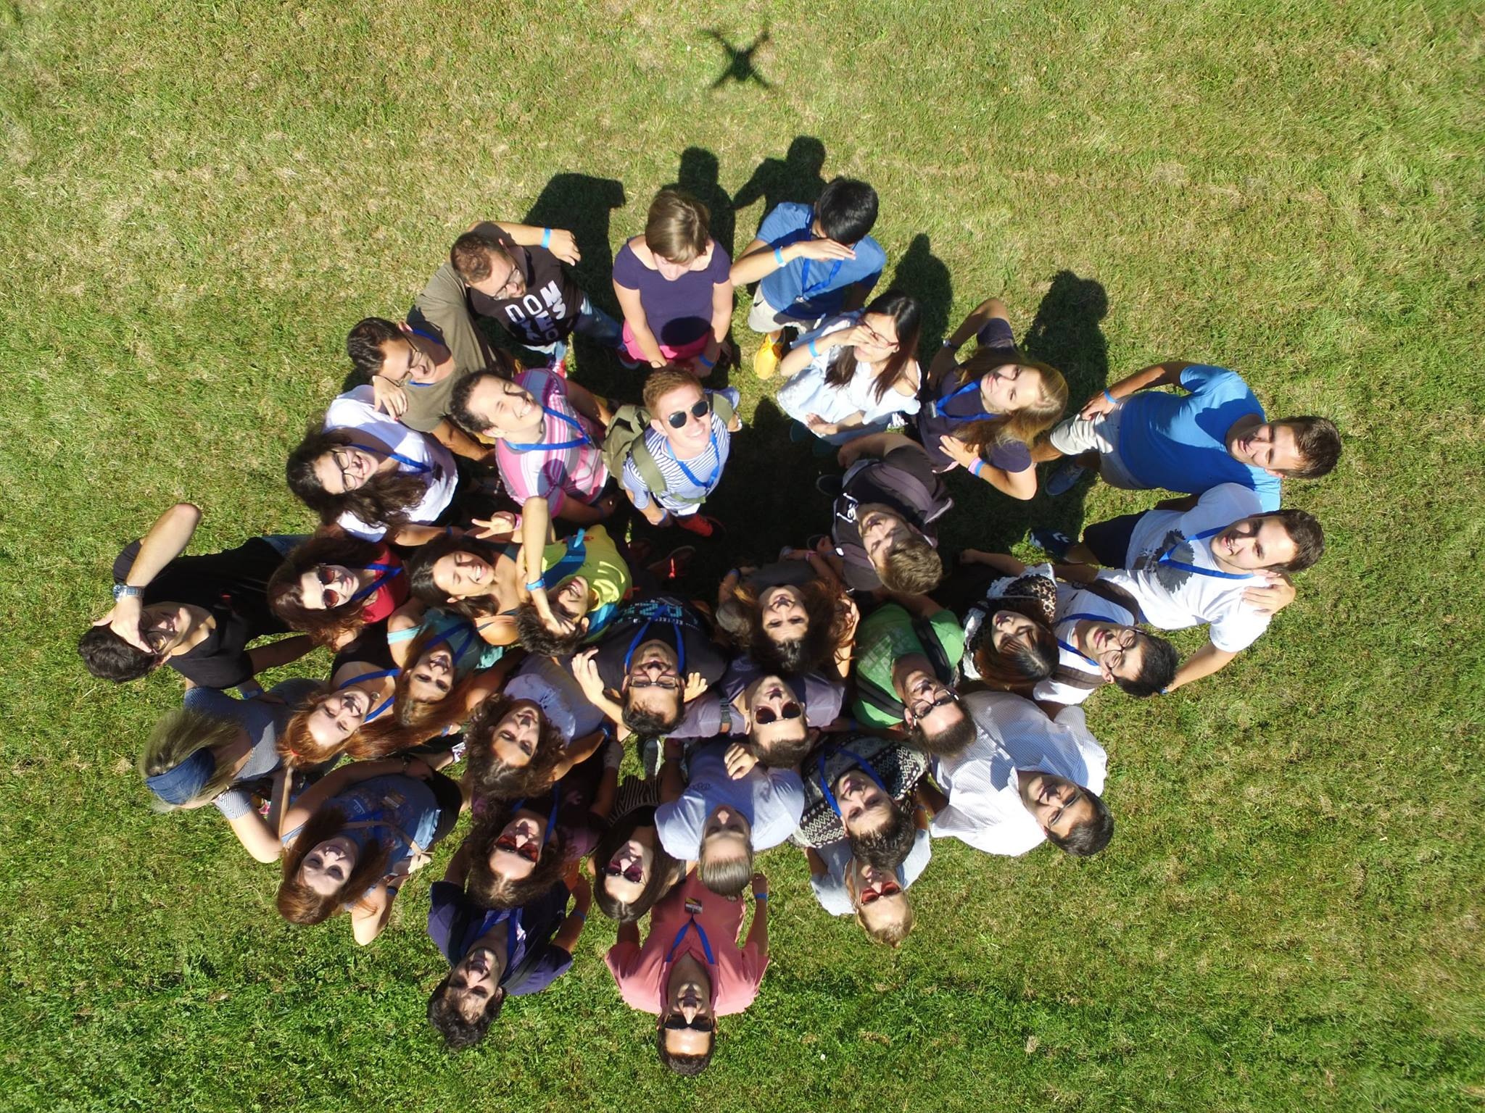

The unique Pécs Debate Academy awaits you in 2017! See you in Pécs!

